# Quiz administration

## Step 1

1. Arrive before asked time 9:30 AM, you should arrive at least 10 minutes arrive.
2. Distribute the paper with tokens (120 pages)
3. Collect immediately leftovers.
4. Count the number of students in the classroom. Take note. Tip: Count and write down the number by row e.g. A:10, B:15
5. Match the number of students with the number of papers. If leftover papers are 7 then there must be 113 students class.
6. Collect all the papers. Tip: Organize it by row

## Step 2

1. Go to moodle and download responses for the quiz.

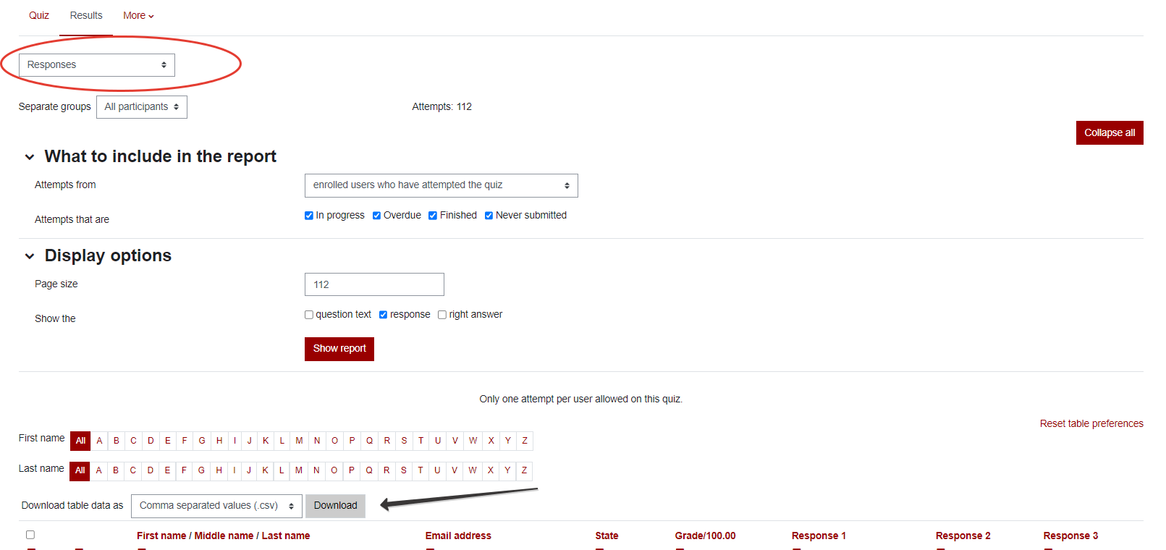

1. Go to the github page (link will be provided later) and run the *token_matcher.ipynb* (make sure that 2 files are in appropriate directories. For example for Quiz 2 the following 2 files are needed:   
   *quiz_2_token.csv* and *CSC 540 (001) FALL 2023-Quiz 2 for Section 001-responses.csv*
2. Find (if any) inconsistencies with the numbers provided, report student names to professor.